**Clean Up Unused IP Addresses**

**Overview**

In this lab, you use [Cloud Functions](https://cloud.google.com/functions/) and [Cloud Scheduler](https://cloud.google.com/scheduler/) to identify and clean up wasted cloud resources. On Google Cloud, [static IP addresses are a free resource](https://cloud.google.com/compute/pricing#ipaddress) when they’re attached to a load balancer or virtual machine (VM) instance. When a static IP address is reserved, but not used, it accumulates an hourly charge. In apps that heavily depend on static IP addresses and large-scale dynamic provisioning, this waste can become significant over time.

What you'll do

* Create a Compute Engine VM with a static external IP address and a separate unused static external IP address
* Deploy a Cloud Function to identify unused addresses
* Create a Cloud Scheduler job to schedule the function to run by using an HTTP trigger

Architecture

The following diagram describes the architecture used in the first section of this lab, where you schedule a Cloud Function to identify and clean up unused IP addresses.

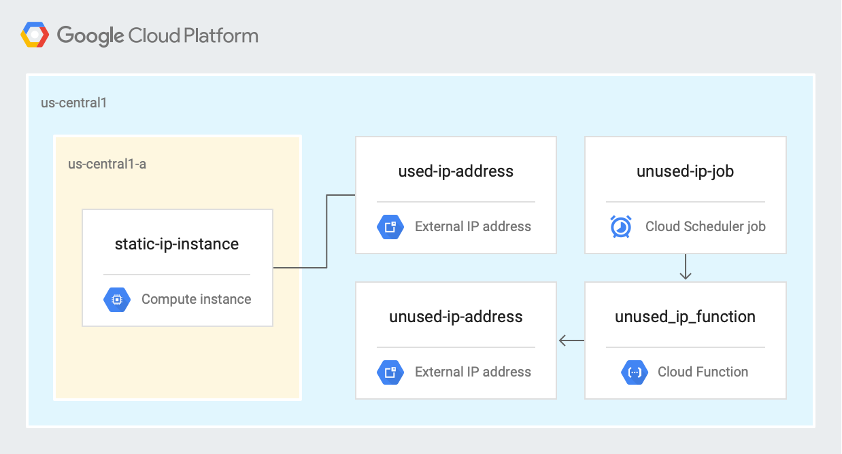

In this lab, you completed the following tasks:

* Created a Compute Engine VM with a static external IP address and a separate unused static external IP address
* Deployed a Cloud Function to identify unused addresses
* Created a Cloud Scheduler job to schedule the function to run by using an HTTP trigger